MAXADOX⁵ WATER PURIFICATION – a summary

ADVANTAGES OF THE MAXADOX⁵ PURIFICATION SYSTEM:
- A world first, with leading edge technology, launched early 2026 after 10 years of research.
- The cheapest and most effective component in a water purification system
- The system basically looks after itself with a little supervision
- Comes with a free APP which allows client to change settings AND warns the client if something or some setting changes.
- Very low power consumption – 200 to 400 watt for a 5 000 litre/hour system, dependent on electrical conductivity.
- Can easily run off solar power – one panel required.
- ROI is generally between 6-18 months.
- OZONE is the best disinfection, with no toxic byproducts. Kills off SRB’s (Sulphur reducing bacteria), E.coli and other pathogens.
- Purified water can be safely used as bottled water.

WHAT IS THE MAXADOX⁵ TECHNOLOGY?
- Maxadox⁵ works using an EKD technology (electrokinetic disruption). This system separates some hydrogen from oxygen in water. Oxygen molecules and hydroxyl radical are formed together with OZONE on demand, a highly effective purifier (see below for more). Excess hydrogen molecules are released with a built in valve.
- Maxadox⁵ uses water itself to create Ozone, remembering that water is made up of 89% oxygen.
- Maxadox⁵, using EKD, creates electromagnetic energy, which then combines with ultra sound inside each reactor cell, destroying unwanted pathogens without affecting the mineral content in the water.
- Maxadox⁵ works at atomic scale (all the way down to a picometer, which is one quadrillionth of a meter in size).
- When required, flocculant dosing is set according to lab results that show the makeup of each clients’ water. Dosing is programmed by our team on installation.
- Pricing excludes a sheet metal cabinet, for outdoor installations mainly.
- Pricing on any size unit only depends on 3 factors – an appropriate lab test of your water, the rate at which you want to pump water, and general water quality.

PREP TANK
PH CONTROL TANK
FLOC TANK

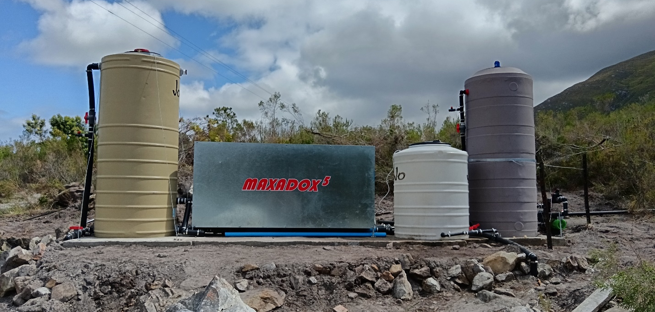
NOTES:
- PREP tank is only necessary if the water quality demands adjustment before the treatment. (NOTE: No lime stone in future)
- FLOC tank is filled with a flocculant, to encourage suspended solids separation.
- PH CONTROL tank brings water up to a suitable PH for efficient treatment.

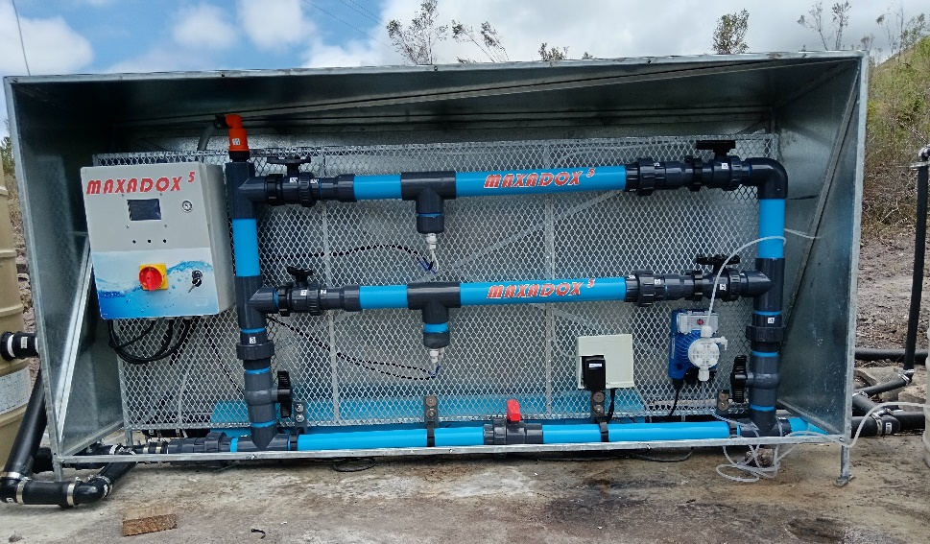

THE MAXADOX⁵ PROCESS
- A lab must first analyze your water – 5-10L is required for “normal” water, 20L is required for water with a high turbidity level, or wastewater.
- Once we receive the lab results, which typically show the mineral composition of up to 20 minerals, and once you give us your expected flow usage rate per hour, we will then design and assemble a system that will maximize the purification process of your water.
- A concrete slab may be required to carry the Maxadox system as well as other equipment and tanks. Total slab measurement is approx. 5m x 1m width (around 75mm thick).
- Floc settles in the third PH UPLIFTER tank – this needs to be flushed briefly once a week.
- An appropriate filter after the process is necessary (we provide links to where you can buy these directly)

MAXADOX⁵ – how it works
- Flocculant gathers suspended solids and other contaminants and removes them from the water.
- Water moves through “reactor cells” which have plates and which produce a combination of electromagnetic charge, electrochemistry and is combined with ultrasound. [Note: the higher the usage rate by the client, the more reactor cells we connect]
- Electromagnetic charge and electrochemistry creates Ozone, which is the most potent purifier of all purifiers (see more below)
- All pathogens and potentially most organic compounds are removed from the water.
- Maxadox⁵ does not affect the mineral composition OR the PH of the water.

“Southern Cape Brown Water” – before, during and after Maxadox treatment
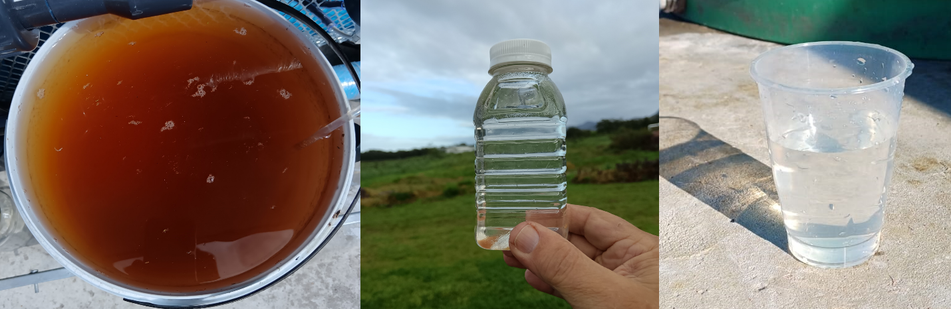

MAXADOX⁵ OZONE PROCESS compared to CHLORINE

When ozone is generated and interacts with the water and other substance in Maxadox⁵ everything is in an environment where oxygen, including ozone, is enhanced by many other interactions. These include electrochemistry, ultrasound, electromagnetic effects and physical influences all working together in perfect harmony. No other process makes its own oxygen and ozone from water and then boosts their performance in this manner.

- Ozone is one of the fastest and most powerful ways to disinfect and clean water available today.
- Ozone works thousands of times faster than chlorine in destroying bacteria, viruses, mould, yeast, cysts, and many other unwanted substances in water.
- When used correctly, ozone can neutralize a wider range of waterborne germs and contaminants than chlorine at practical treatment levels.
- Ozone can greatly reduce the need for strong chemicals such as chlorine and can also lower the harmful by-products linked to chlorine use.
- Unlike chlorine, ozone does not leave behind harmful chemical residues in the water. Any unused ozone naturally changes back into oxygen.
- Ozone purifies water far more quickly than traditional chlorine-based treatment methods.
- Ozone does not leave an unpleasant chemical taste or smell in the water.
- Water treated with ozone is gentler on the skin, nose, and eyes and does not leave a chemical layer or drying effect on the skin.
- Ozone can break down oils and many other unwanted materials found in water.
- Ozone treatment is environmentally friendly because it does not leave long-lasting chemical pollution behind.
- Ozone treatment continues to work effectively across different water conditions and does not significantly change the water’s balance.
- Ozone can help small particles clump together, making minerals such as iron and manganese easier to remove from the water.
- Ozone systems produce ozone on-site, removing the need to transport or store hazardous treatment chemicals.
- Excess ozone does not remain trapped in the water and naturally changes back into oxygen.
- Ozone treatment levels can be checked easily using simple monitoring equipment.
- Ozone is generally less damaging to equipment and pipework in water systems than chlorine.

FAQ’s
- Does Maxadox⁵ neutralize/destroy PFAS’s completely (whereas most other processes wont do this)?
Indications from compounds that we have already disrupted are that we can do this, and we will shortly be beginning testing to prove it.
- How effective is UV light?
If water contains small particles of sediment, this affects the efficiency of UV lighting – bacteria hide in or behind particles of sediment. In addition UV lights also can build up coatings and have a limited life span, and may not indicate to the client whether they are working or not.
- Will Maxadox ⁵remove all or most forever chemicals?
Yes, this is what we expect, although the methodology is quite different to what others are using. Test results will be available in the near future.
- How many reactor cells are required?
Maxadox⁵ units step up from 1x 63mm diameter reactor cell to 2, or more, and we can keep adding similar to RO for bigger flow rates, but it reaches a point where too many small ones become costly, and it is therefore better to use larger cells at that point. For example, basic flow rates up to about 10m³/h will need 4 reactor cells, for more than 8 in total we need check cost and weigh up cost advantages of using larger cells. Obviously as the flow rate increases then the pipe sizes, pumps, tanks and filters all increase in size as well. The next size up of reactor cell, namely 160mm diameter, will do roughly 40 to 80m³/h depending on water quality.
- Can Maxadox⁵ be used on sea water?
Potentially yes – we still need to test this.
- Who installs the Maxadox⁵ system?
We will appoint plumbers in an area that will do this and perform maintenance.

RO is designed to remove everything except water from the water, it is unhealthy because all minerals are removed and will consequently leach from your body, it is an expensive and expensive to run – uses high energy per volume, needs constant care and cleaning, has a waste stream that is difficult to correctly dispose of, doesn’t disinfect reliably, can’t easily adapt to quality changes, does generally not communicate.
Max doesn’t cost nearly as much – uses negligible energy per volume, is robust and can deal with most types of water, keeps the minerals and makes them easier to metabolise, disinfects better than chlorine, produces no toxic products, cleans itself and needs little maintenance, adjusts to water quality changes, leaves the water oxygenated (like mountain stream water), produces a small amount of waste that has only undesirable components originating from the water, advises when it is not operating correctly and needs attention 9via our FREE APP), can communicate with online systems for warnings and adjustment.

For all technical or chemical questions – fill in the website “contact” form, we will email you the correct information: name, email address and mobile number.

