PURIFICATION OF WATER (for disaster relief)
Introducing the PURIBAG
- Imported from Australia
- Certified by the WHO (supporting document can be sent)
- Turns 10L of murky water containing pathogenic microorganisms into safe drinkable water, within 30 minutes
- Each 10L bag comes with 10 x purification sachets, each sachet capable of purifying 10 L of water.
- Handles high and low turbidity in water.
- Combines filter technologies consisting of flocculation, chlorine disinfection and carbon filtration.
- Weighs approx. 200g per unit (inexpensive to freight).
- Removes waste in-situ
- Removal of 99% of bacteria, intestinal viruses and protozoa.

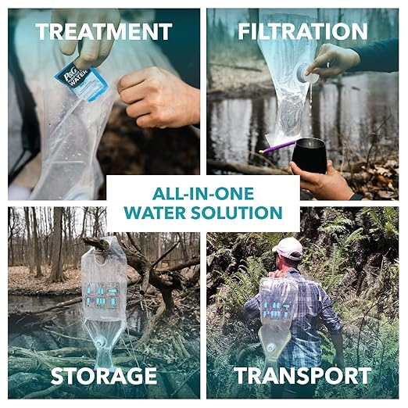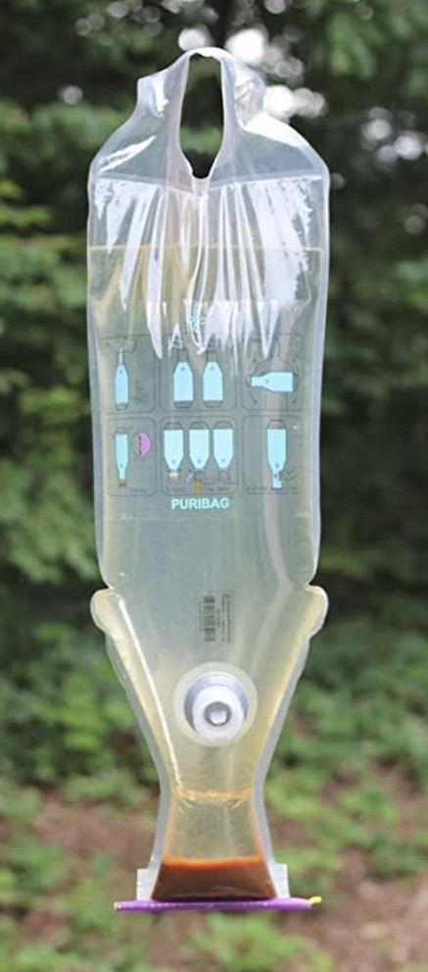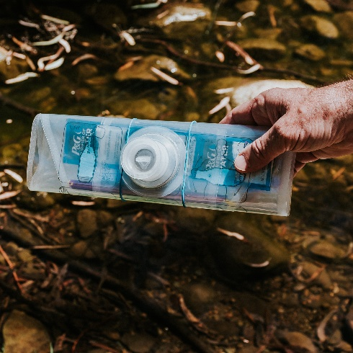

For more information, fill in the form under CONTACTS – we will get back to.

